Ex.No.4: OFDMA Resource Block Allocation
AIM:
To simulate and analyze OFDMA (Orthogonal Frequency Division Multiple Access) resource block allocation and evaluate system performance in terms of resource utilization and user throughput using MATLAB.

Objectives:
1. To determine the Number of Resource Blocks (RBs) allocated in an OFDMA system based on available bandwidth and system configuration.
2. To evaluate the Resource Block Utilization (%) by analyzing how efficiently available RBs are assigned to active users.
3. To calculate the User Throughput (Mbps) based on allocated resource blocks and modulation efficiency in the OFDMA system.
Objective 1 Matlab Code and Output:
clc; clear; close all;

% System parameters
bandwidth = 10e6; % 10 MHz
rb_size = 180e3; % 180 kHz per RB

% Total Resource Blocks
total_RB = floor(bandwidth / rb_size);

% Users
users = 1:6;

% RB allocation (simple equal + remainder distribution) base = floor(total_RB / length(users));
alloc = base * ones(1,length(users)); alloc(1:mod(total_RB,length(users))) = alloc(1:mod(total_RB,length(users))) + 1;

utilization = (alloc / total_RB) * 100;

disp('Total Resource Blocks:') disp(total_RB)

disp('RB Allocation per User:') disp(alloc)

figure

% -------- Graph 1: RB Allocation per User -------- subplot(2,1,1)
stem(users, alloc, 'filled', 'LineWidth', 2) title('OFDMA Resource Block Allocation per User')
xlabel('User Index') ylabel('Number of Resource Blocks')
grid on

% -------- Graph 2: RB Utilization -------- subplot(2,1,2) plot(users, utilization, '-o', 'LineWidth', 2) title('OFDMA Resource Block Utilization (%)')
xlabel('User Index') ylabel('Utilization (%)') grid on
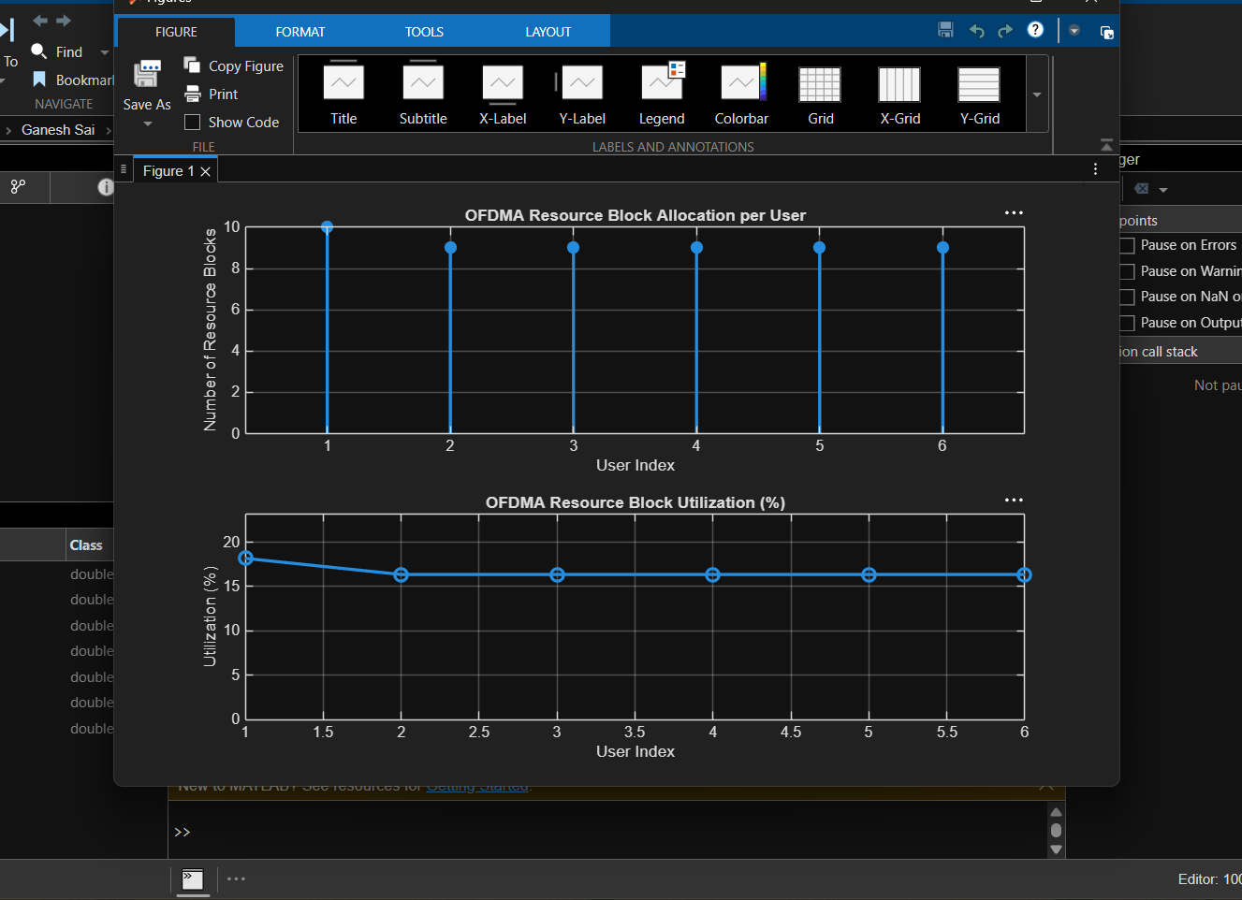
Objective 2 Matlab Code and Output:
clc; clear; close all;

% Total system resource blocks total_RB = 50;

% Number of active users
users = 1:5;

% RB allocation to users (example scenario)
alloc = [12 10 9 8 11];

% Resource Block Utilization (%)
util = (alloc / total_RB) * 100;

disp('Resource Block Utilization (%) per User:') disp(util')

figure

% -------- Graph 1: RB Allocation -------- subplot(2,1,1)
plot(users, alloc, '-o', 'LineWidth', 2) title('OFDMA Resource Block Allocation per User') xlabel('User Index') ylabel('Number of Resource Blocks') grid on

% -------- Graph 2: Utilization (%) -------- subplot(2,1,2)
plot(users, util, '-s', 'LineWidth', 2) title('OFDMA Resource Block Utilization (%)')
xlabel('User Index') ylabel('Utilization (%)') grid on
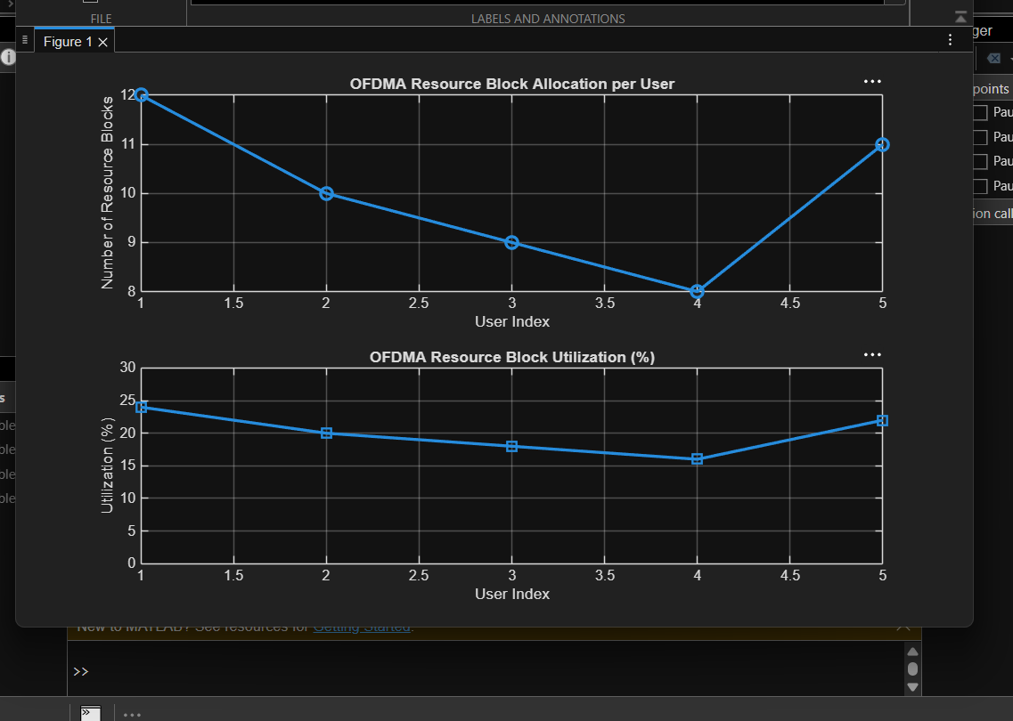
Objective 3 Matlab Code and Output:
clc; clear; close all;

% System parameters
rb_bw = 180e3; % Bandwidth per RB (180 kHz) users = 1:5;

% Allocated Resource Blocks per user alloc_RB = [12 10 9 8 11];

% Modulation efficiency (bits/symbol) mod_eff = [2 4 6 4 2]; % QPSK, 16QAM, 64QAM etc.

% Throughput calculation (Mbps)
throughput = (alloc_RB .* rb_bw .* mod_eff) / 1e6;

disp('User Throughput (Mbps):') disp(throughput')

figure

% -------- Graph 1: Throughput per User -------- subplot(2,1,1)
plot(users, throughput, '-o', 'LineWidth', 2) title('OFDMA User Throughput') xlabel('User Index') ylabel('Throughput (Mbps)')
grid on

% -------- Graph 2: RB vs Throughput -------- subplot(2,1,2) plot(alloc_RB, throughput, '-s', 'LineWidth', 2) title('Resource Blocks vs Throughput Relationship') xlabel('Allocated Resource Blocks') ylabel('Throughput (Mbps)')
grid on
